**With 0 speed**

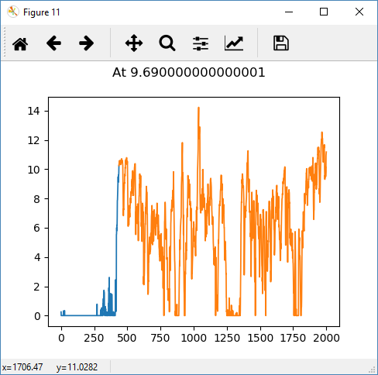

Anchors at 9.690000000000001 : [ 0. 436. 1999.]

No. of Anchors at 9.690000000000001 : 3

Time for 9.690000000000001 : 0.2798802852630615

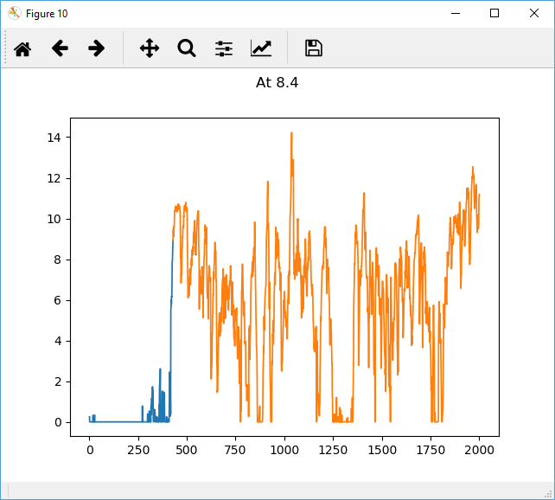

Anchors at 8.4 : [ 0. 428. 1999.]

No. of Anchors at 8.4 : 3

Time for 8.4 : 0.3083760738372803

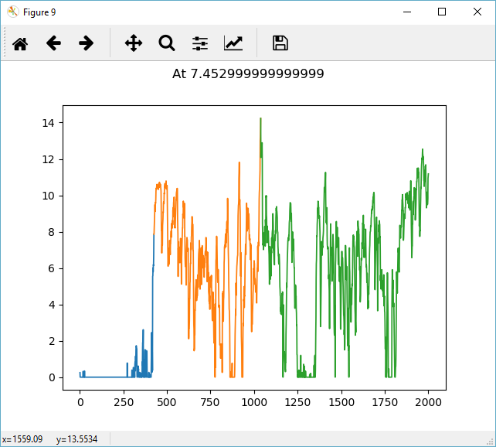

Anchors at 7.452999999999999 : [ 0. 424. 1037. 1999.]

No. of Anchors at 7.452999999999999 : 4

Time for 7.452999999999999 : 0.48000097274780273

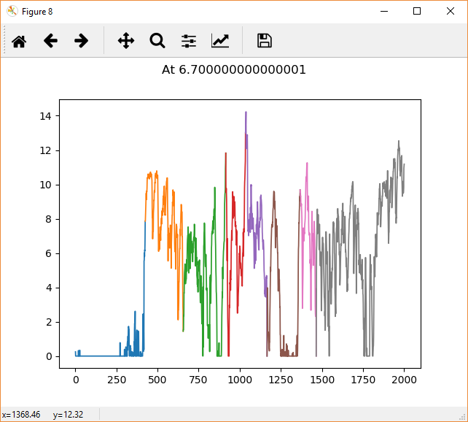

Anchors at 6.700000000000001 : [ 0. 424. 655. 914. 1034. 1165. 1366. 1464. 1999.]

No. of Anchors at 6.700000000000001 : 9

Time for 6.700000000000001 : 0.37627744674682617

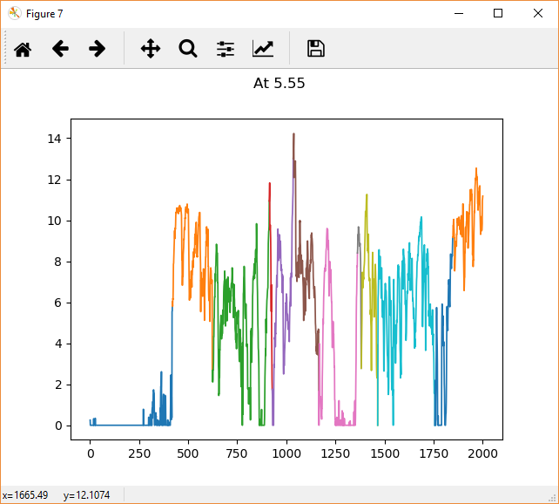

Anchors at 5.55 : [ 0. 419. 622. 912. 927. 1034. 1164. 1361. 1380. 1464. 1755. 1846. 1999.]

No. of Anchors at 5.55 : 13

Time for 5.55 : 0.34000444412231445

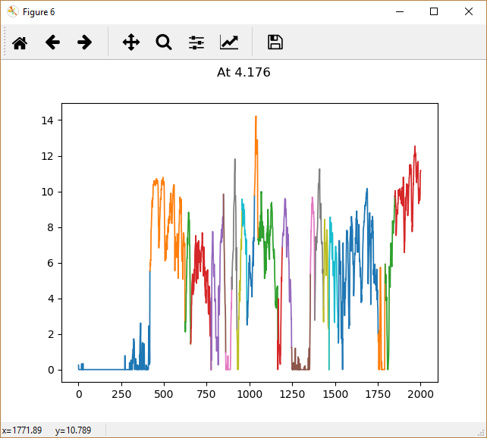

Anchors at 4.176 : [ 0. 417. 622. 655. 775. 847. 860. 895. 926. 955. 984. 1028.

1049. 1164. 1191. 1245. 1355. 1380. 1431. 1464. 1518. 1751. 1792. 1848. 1999.]

No. of Anchors at 4.176 : 25

Time for 4.176 : 0.47199010848999023

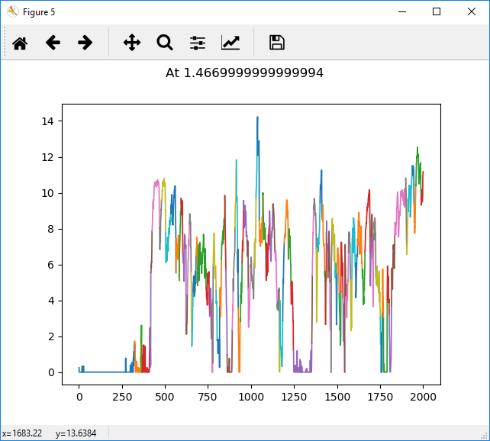

Anchors at 1.4669999999999994 : [ 0. 322. 360. 364. 411. 417. 424. 467. 479. 503. 533. 563. 582. 593. 603. 622. 629. 641. 651. 655. 662. 680. 689. 738.759. 769. 775. 777. 779. 796. 802. 817. 827. 847. 853. 860. 890. 895. 906. 914. 921. 925. 936. 947. 955. 978. 983. 995. 1020. 1028. 1034. 1047. 1067. 1086. 1106. 1126. 1138. 1151. 1164. 1167. 1183. 1192. 1216. 1231. 1245. 1352. 1355. 1363. 1378. 1385. 1400. 1412. 1427. 1432. 1437. 1446. 1457. 1464. 1470. 1487. 1495. 1499. 1511. 1521. 1533. 1543. 1551. 1565. 1577. 1585. 1605. 1618. 1645. 1661. 1691. 1697. 1706. 1711. 1724. 1750. 1755. 1762. 1768. 1790. 1802. 1815. 1834. 1898. 1903. 1910. 1936. 1946. 1956. 1987. 1999.]

No. of Anchors at 1.4669999999999994 : 115

Time for 1.4669999999999994 : 1.109687089920044

**Code**

start = time.time()

for i in

np.percentile(data,[10,20,30,40,50,60,70,80,90]):

s1 = time.time()

s = SlidingWindowSegmentation(file,data,i)

print("Anchors at ",i," : ",s.get_anchor())

s2 = time.time()

print("No. of Anchors at ",i," : ",

s.get_anchor_length())

print("\nTime for ",i," : ",s2-s1,"\n")

print("\nTotal Time : ",time.time()-start)

**Output**

Anchors at 0.0 : [0.000e+00 0.000e+00 1.000e+00 ... 1.997e+03 1.998e+03 1.999e+03]

No. of Anchors at 0.0 : 2001

Time for 0.0 : 19.59736394882202

Anchors at 0.0 : [0.000e+00 0.000e+00 1.000e+00 ... 1.997e+03 1.998e+03 1.999e+03]

No. of Anchors at 0.0 : 2001

Time for 0.0 : 19.224189043045044

Anchors at 1.4669999999999994 : [ 0. 322. 360. 364. 411. 417. 424. 467. 479. 503. 533. 563.

582. 593. 603. 622. 629. 641. 651. 655. 662. 680. 689. 738.

759. 769. 775. 777. 779. 796. 802. 817. 827. 847. 853. 860.

890. 895. 906. 914. 921. 925. 936. 947. 955. 978. 983. 995.

1020. 1028. 1034. 1047. 1067. 1086. 1106. 1126. 1138. 1151. 1164. 1167.

1183. 1192. 1216. 1231. 1245. 1352. 1355. 1363. 1378. 1385. 1400. 1412.

1427. 1432. 1437. 1446. 1457. 1464. 1470. 1487. 1495. 1499. 1511. 1521.

1533. 1543. 1551. 1565. 1577. 1585. 1605. 1618. 1645. 1661. 1691. 1697.

1706. 1711. 1724. 1750. 1755. 1762. 1768. 1790. 1802. 1815. 1834. 1898.

1903. 1910. 1936. 1946. 1956. 1987. 1999.]

No. of Anchors at 1.4669999999999994 : 115

Time for 1.4669999999999994 : 1.109687089920044

Anchors at 4.176 : [ 0. 417. 622. 655. 775. 847. 860. 895. 926. 955. 984. 1028.

1049. 1164. 1191. 1245. 1355. 1380. 1431. 1464. 1518. 1751. 1792. 1848.

1999.]

No. of Anchors at 4.176 : 25

Time for 4.176 : 0.47199010848999023

Anchors at 5.55 : [ 0. 419. 622. 912. 927. 1034. 1164. 1361. 1380. 1464. 1755. 1846.

1999.]

No. of Anchors at 5.55 : 13

Time for 5.55 : 0.34000444412231445

Anchors at 6.700000000000001 : [ 0. 424. 655. 914. 1034. 1165. 1366. 1464. 1999.]

No. of Anchors at 6.700000000000001 : 9

Time for 6.700000000000001 : 0.37627744674682617

Anchors at 7.452999999999999 : [ 0. 424. 1037. 1999.]

No. of Anchors at 7.452999999999999 : 4

Time for 7.452999999999999 : 0.48000097274780273

Anchors at 8.4 : [ 0. 428. 1999.]

No. of Anchors at 8.4 : 3

Time for 8.4 : 0.3083760738372803

Anchors at 9.690000000000001 : [ 0. 436. 1999.]

No. of Anchors at 9.690000000000001 : 3

Time for 9.690000000000001 : 0.2798802852630615

Total Time : 42.19570064544678

**Without 0 speed**

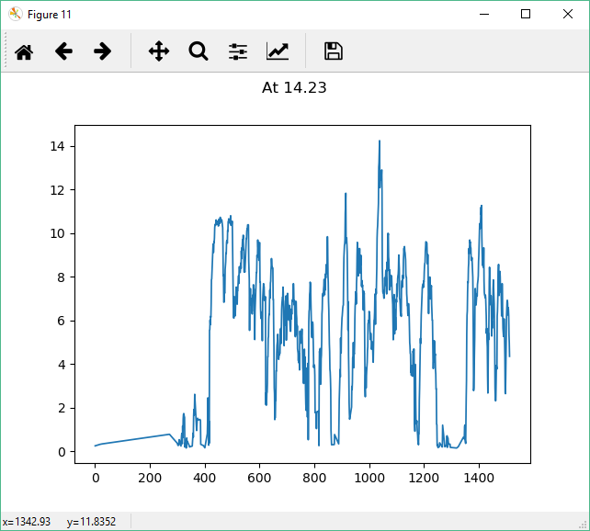

Anchors at 14.23 : [ 0. 1511.]

No. of Anchors at 14.23 : 2

Time for 14.23 : 0.2343747615814209

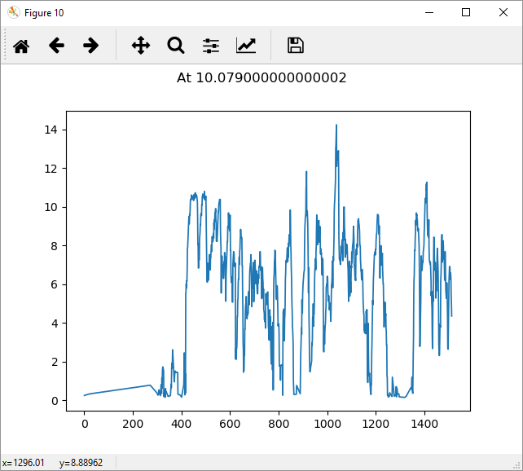

Anchors at 10.079000000000002 : [ 0. 1511.]

No. of Anchors at 10.079000000000002 : 2

Time for 10.079000000000002 : 0.2343730926513672

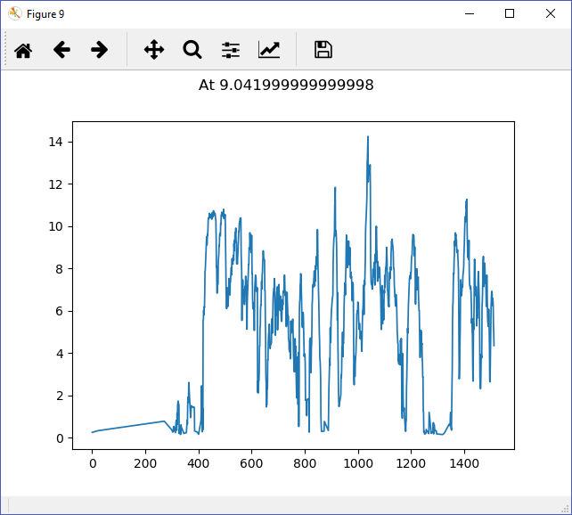

Anchors at 9.041999999999998 : [ 0. 1511.]

No. of Anchors at 9.041999999999998 : 2

Time for 9.041999999999998 : 0.2342548370361328

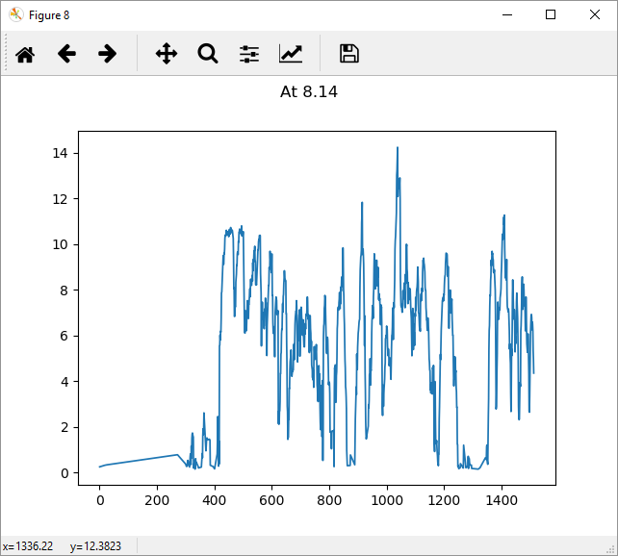

Anchors at 8.14 : [ 0. 1511.]

No. of Anchors at 8.14 : 2

Time for 8.14 : 0.23437094688415527

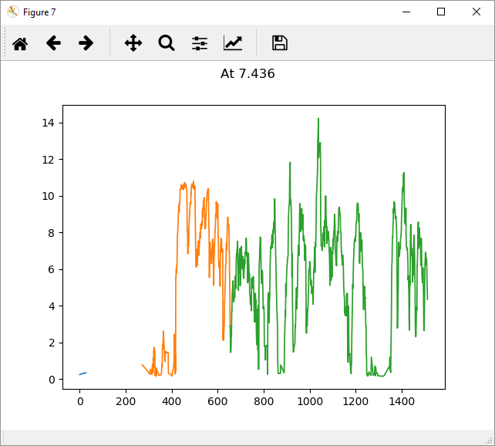

Anchors at 7.436 : [ 0. 83. 653. 1511.]

No. of Anchors at 7.436 : 4

Time for 7.436 : 0.2501084804534912

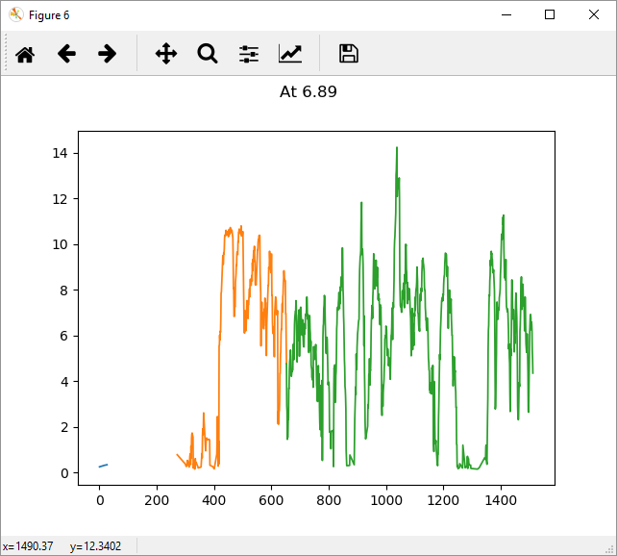

Anchors at 6.89 : [ 0. 75. 652. 1511.]

No. of Anchors at 6.89 : 4

Time for 6.89 : 0.2514481544494629

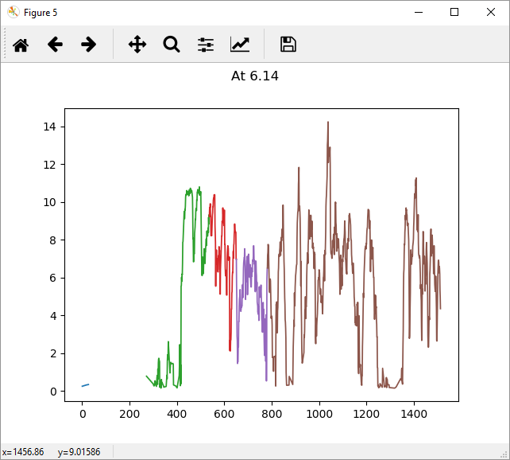

Anchors at 6.14 : [ 0. 71. 269. 536. 650. 781. 1511.]

No. of Anchors at 6.14 : 7

Time for 6.14 : 0.2501223087310791

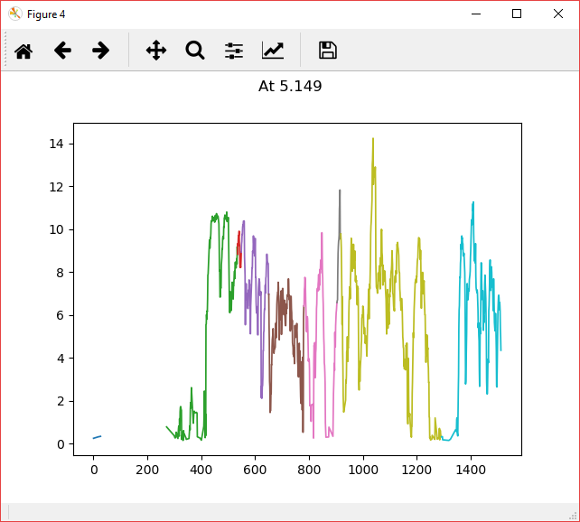

Anchors at 5.149 : [ 0. 70. 269. 534. 548. 650. 780. 903. 917. 1290. 1511.]

No. of Anchors at 5.149 : 11

Time for 5.149 : 0.2866981029510498

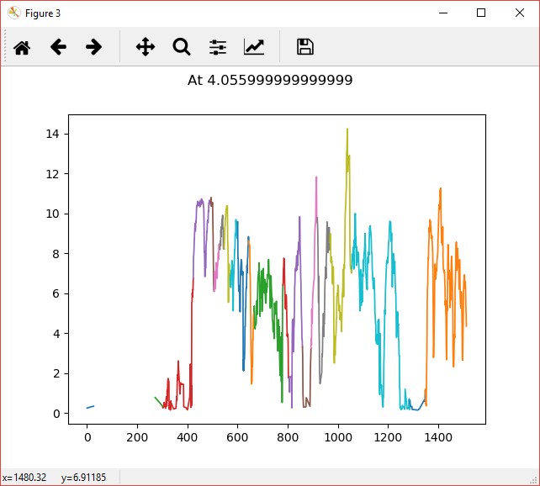

Anchors at 4.055999999999999 : [ 0. 64. 269. 302. 423. 493. 506. 529. 546. 571. 600. 644.

665. 780. 806. 858. 892. 917. 968. 1054. 1286. 1347. 1511.]

No. of Anchors at 4.055999999999999 : 23

Time for 4.055999999999999 : 0.374997615814209

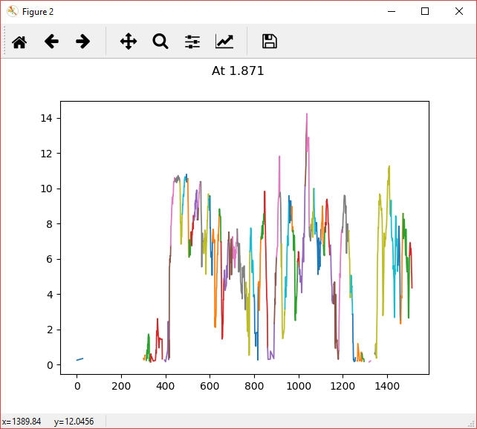

Anchors at 1.871 : [ 0. 64. 76. 114. 151. 184. 210. 237. 250. 269. 278. 299. 310. 332. 388. 415. 423. 443. 464. 475. 493. 500. 506. 515. 528. 543. 548. 557. 570. 594. 599. 611. 642. 650. 663. 683. 702. 723. 762. 780. 799. 819. 831. 846. 860. 890. 900. 915. 922. 938. 956. 968. 974. 995. 1002. 1029. 1036. 1048. 1058. 1069. 1079. 1101. 1112. 1120. 1143. 1157. 1181. 1197. 1226. 1234. 1243. 1259. 1286. 1296. 1302. 1305. 1318. 1327. 1347. 1415. 1448. 1459. 1471. 1500. 1511.]

No. of Anchors at 1.871 : 85

Time for 1.871 : 0.7999491691589355

**Code**

start = time.time()

for i in np.percentile(d,[0,10,20,30,40,50,60,70,80,90,100]):

s1 = time.time()

s = SlidingWindowSegmentation(f,d,i)

print("Anchors at ",i," : ",s.get_anchor())

s2 = time.time()

print("No. of Anchors at ",i," : ",s.get_anchor_length())

print("Time for ",i," : ",s2-s1,"\n")

print("\nTotal Time : ",time.time()-start)

**Output**

Anchors at 0.15 : [ 0. 3. 9. 12. 14. 16. 18. 24. 27. 32. 35. 37. 41. 43. 53. 56. 58. 60. 62. 64. 66. 68. 70. 73. 75. 78. 80. 83. 88. 98. 111. 113. 116. 118. 121. 124. 126. 130. 132. 141. 148. 150. 152. 154. 157. 159. 161. 163. 166. 169. 171. 178. 180. 182. 184. 188. 190. 194. 196. 198. 200. 207. 209. 211. 213. 216. 219. 221. 224. 227. 229. 231. 233. 235. 237. 240. 244. 246. 248. 250. 256. 258. 261. 264. 269. 271. 273. 275. 278. 280. 283. 285. 288. 290. 296. 298. 300. 302. 305. 307. 309. 313. 315. 322. 325. 327. 332. 334. 336. 340. 344. 346. 348. 350. 353. 355. 357. 361. 363. 365. 369. 372. 375. 377. 379. 381. 383. 385. 388. 390. 392. 396. 400. 402. 404. 406. 409. 411. 414. 416. 418. 420. 422. 424. 426. 428. 430. 432. 434. 438. 441. 443. 447. 453. 462. 464. 468. 470. 472. 475. 479. 482. 484. 486. 488. 490. 493. 495. 497. 499. 501. 504. 506. 509. 511. 513. 515. 517. 520. 523. 528. 530. 533. 536. 541. 543. 545. 547. 549. 551. 554. 557. 559. 562. 564. 566. 568. 570. 572. 576. 578. 580. 582. 585. 587. 592. 594. 598. 600. 602. 604. 607. 609. 611. 615. 618. 623. 626. 629. 631. 633. 635. 637. 639. 642. 644. 647. 650. 652. 654. 661. 663. 665. 669. 672. 675. 678. 680. 683. 686. 688. 690. 692. 695. 698. 701. 703. 705. 707. 709. 712. 714. 716. 719. 722. 724. 726. 729. 733. 736. 738. 740. 742. 747. 749. 752. 754. 756. 758. 761. 763. 765. 767. 769. 774. 780. 782. 784. 790. 794. 797. 799. 801. 803. 805. 807. 813. 815. 819. 823. 826. 828. 830. 832. 835. 837. 839. 842. 844. 846. 848. 851. 854. 856. 858. 860. 862. 869. 873. 875. 883. 885. 887. 889. 891. 893. 895. 898. 900. 903. 906. 908. 912. 914. 916. 919. 921. 923. 926. 931. 934. 936. 938. 943. 945. 947. 949. 954. 956. 962. 964. 966. 968. 970. 973. 975. 977. 980. 982. 984. 987. 989. 991. 993. 995. 999. 1002. 1004. 1006. 1008. 1010. 1012. 1014. 1017. 1020. 1022. 1025. 1027. 1029. 1031. 1033. 1035. 1037. 1041. 1044. 1046. 1048. 1051. 1054. 1057. 1062. 1064. 1066. 1068. 1070. 1073. 1075. 1077. 1079. 1081. 1084. 1086. 1089. 1092. 1094. 1096. 1099. 1101. 1107. 1110. 1112. 1115. 1117. 1119. 1121. 1124. 1127. 1129. 1133. 1137. 1139. 1142. 1145. 1147. 1149. 1153. 1156. 1161. 1164. 1166. 1171. 1174. 1176. 1180. 1183. 1185. 1187. 1189. 1192. 1194. 1196. 1199. 1203. 1206. 1208. 1213. 1215. 1219. 1224. 1226. 1229. 1231. 1233. 1236. 1238. 1241. 1243. 1245. 1249. 1251. 1253. 1256. 1258. 1260. 1266. 1268. 1270. 1274. 1277. 1279. 1281. 1283. 1285. 1287. 1290. 1292. 1294. 1296. 1299. 1301. 1305. 1307. 1309. 1313. 1317. 1319. 1321. 1325. 1327. 1329. 1331. 1334. 1336. 1341. 1345. 1347. 1349. 1353. 1357. 1360. 1364. 1366. 1368. 1371. 1378. 1381. 1388. 1393. 1399. 1401. 1404. 1407. 1409. 1411. 1413. 1415. 1418. 1420. 1422. 1425. 1428. 1430. 1435. 1437. 1440. 1442. 1444. 1448. 1453. 1457. 1459. 1461. 1463. 1465. 1467. 1470. 1473. 1477. 1479. 1483. 1485. 1487. 1489. 1491. 1496. 1498. 1500. 1503. 1506. 1509. 1511.]

No. of Anchors at 0.15 : 541

Time for 0.15 : 4.693488597869873

Anchors at 1.871 : [ 0. 64. 76. 114. 151. 184. 210. 237. 250. 269. 278. 299. 310. 332. 388. 415. 423. 443. 464. 475. 493. 500. 506. 515. 528. 543. 548. 557. 570. 594. 599. 611. 642. 650. 663. 683. 702. 723. 762. 780. 799. 819. 831. 846. 860. 890. 900. 915. 922. 938. 956. 968. 974. 995. 1002. 1029. 1036. 1048. 1058. 1069. 1079. 1101. 1112. 1120. 1143. 1157. 1181. 1197. 1226. 1234. 1243. 1259. 1286. 1296. 1302. 1305. 1318. 1327. 1347. 1415. 1448. 1459. 1471. 1500. 1511.]

No. of Anchors at 1.871 : 85

Time for 1.871 : 0.7999491691589355

Anchors at 4.055999999999999 : [ 0. 64. 269. 302. 423. 493. 506. 529. 546. 571. 600. 644. 665. 780. 806. 858. 892. 917. 968. 1054. 1286. 1347. 1511.]

No. of Anchors at 4.055999999999999 : 23

Time for 4.055999999999999 : 0.374997615814209

Anchors at 5.149 : [ 0. 70. 269. 534. 548. 650. 780. 903. 917. 1290. 1511.]

No. of Anchors at 5.149 : 11

Time for 5.149 : 0.2866981029510498

Anchors at 6.14 : [ 0. 71. 269. 536. 650. 781. 1511.]

No. of Anchors at 6.14 : 7

Time for 6.14 : 0.2501223087310791

Anchors at 6.89 : [ 0. 75. 652. 1511.]

No. of Anchors at 6.89 : 4

Time for 6.89 : 0.2514481544494629

Anchors at 7.436 : [ 0. 83. 653. 1511.]

No. of Anchors at 7.436 : 4

Time for 7.436 : 0.2501084804534912

Anchors at 8.14 : [ 0. 1511.]

No. of Anchors at 8.14 : 2

Time for 8.14 : 0.23437094688415527

Anchors at 9.041999999999998 : [ 0. 1511.]

No. of Anchors at 9.041999999999998 : 2

Time for 9.041999999999998 : 0.2342548370361328

Anchors at 10.079000000000002 : [ 0. 1511.]

No. of Anchors at 10.079000000000002 : 2

Time for 10.079000000000002 : 0.2343730926513672

Anchors at 14.23 : [ 0. 1511.]

No. of Anchors at 14.23 : 2

Time for 14.23 : 0.2343747615814209

Total Time : 7.859811544418335

With 0 m/sec speed

|  |  |  |
| --- | --- | --- |
| Threshold | Percentile | No. of Anchors |
| 6.7 | 60% | 9 |
| 5.55 | 50% | 13 |
| 4.176 | 40% | 25 |

Without 0 m/sec speed

|  |  |  |
| --- | --- | --- |
| Threshold | Percentile | No. of Anchors |
| 5.149 | 30% | 11 |
| 4.056 | 20% | 23 |